Asian Parliamentary Assembly (APA)

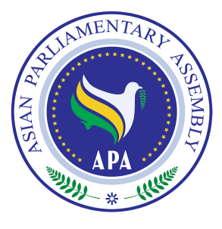

Report
of the Secretary General
on

Global Financial Crisis in Asia:
Global Economy on the Mend, but Recovery Fragile

SG/Rep/2010/08
16 May 2010

Background

The Third Session of the Plenary of the Asian Parliamentary Assembly in Jakarta, Indonesia (2008) in its Resolution -on Ramifications of International Financial Crisis for the Economies of the Countries of APA Member Parliaments, contained in document APA/Res/2008/05, Decided to establish a Sub-Committee on Financial and Economic Crisis, composed of delegates from at least seven Member Parliaments. The Sub-Committee was instructed to hold at least two meetings to address the economic and social ramifications of the international economic crisis on the economies of Asian countries, the role of financial policies of the United States in creating the crisis, propose ways and means to control, -manage and formulate an exit strategy from the crisis, and to submit its report to the Plenary in Bandung in 2009.
The First Meeting of the Sub-Committee as constituted above was held in Kuala Lumpur from 23 to 24 February 2009. The Secretary-General of APA presented a report to this meeting and discussed how the crisis had begun as well as its impacts and repercussions. He also made a number of recommendations to the Sub-Committee. The Sub-Committee deliberated on the report and finally adopted a resolution- attached for further consideration.
The Second Meeting of the Sub-Committee was held in Amman, Jordan, from 27-28 May 2009. The Secretary General of APA presented another report to the Meeting and discussed the concrete proposals on how to deal with the financial crisis in Asia. APA Member Parliaments participating in the Meeting also presented their National Reports on how to deal with the Global Financial Crisis. The Sub-Committee discussed the Secretary-General’s report and finally adopted a complementary resolution -attached for further consideration.

The Fourth Session of the Plenary of the Asian Parliamentary Assembly in Bandung, Indonesia (2009) adopted a resolution on Ramifications of International Financial Crisis for the Economies of the Countries of APA Member Parliaments, contained in document APA/Res/2009/05 and Decided on the extension of the mandate of the Sub-Committee to review the relevant developments in the on-going financial crisis, and to propose ways and means to control, manage and formulate exit strategy from the crisis and submit its report to the Plenary. The present Report of the Secretary-General is submitted to the Sub-Committee for its consideration.

The whole trend of Global Financial Crisis in Asia

Following a deep and widespread contraction in economic activity on a global scale, indications are that the worst is over in different parts of the world. The global economy is expected to grow by about 2.4% in 2010, due mainly to massive and concerted action by major economies. According to the UN annual report (2010), an increasing number of countries have experienced growth of gross domestic product (GDP), along with a notable recovery in international trade and global industrial production. The modest pace of economic recovery appears to indicate that the major developed economies are not expected to provide a strong impetus to high levels of global growth in the near term. The overall situation in Asia seems to be in a better position. Output growth in the Asian developing countries, in contrast is expected to recover at a faster pace and to reach 5.3% in 2010, up from 1.9% in 2009, and also expected to show the strongest recovery in 2010. Nonetheless, growth is expected to remain well below potential and the pre-crisis levels of performance in the developing world.

The current optimistic scenario depends, however, to a large extent, on the relationship between the US economy (with the world’s largest deficit) and the Chinese economy (with the world's largest surplus). Given the US dollar’s central place in the international monetary and reserve system, international monetary and financial stability in the future depends significantly on the US spending discipline and balance-of-payments adjustment. Moreover, tightened global financial conditions will have negative effects on those developing and emerging economies in Asia suffering from structural external deficits and are hence dependent on capital inflows to sustain acceptable growth.
Since the current economic revival is driven mainly by the effects of massive policy interventions since late 2008, the recovery is uneven and conditions for sustained growth remain fragile. Therefore, there are two risks involved; first the risk of an early withdrawal of monetary and fiscal stimulus, and second, the risk of renewed widening of the global macroeconomic imbalances (sharp increase in the US external debt and pressure on the dollar leading to another round of financial instability). Moreover, the current prospects for private sector increased activity does not seem promising, leading to the conclusion that the governments' stabilizing action should continue for the time being to prevent a real big danger of a second-dip recession occurring".
Market-driven globalization during the past two decades or so has systematically tilted the balance of economic power against labor and in favor of capital – almost everywhere. This is also evident in the fact that there is a clear disconnect between the financial markets and the real economy. No wonder that the financial markets "recovered" much earlier than the real economy. The significant structural risk involved here is that without restoring the balance between labor and capital, stability or growth may not be sustained for long.

While there exists widespread belief in the necessity and urgency of reform of the global financial architecture, there are few concrete signs that such a reform is on the agenda of the major economies or the international community at large. Equally important is the necessity of adjustment in the major economies with the aim of removing imbalances. Adjustment and reform are needed in order to ease the payments constraints of deficit and indebted developing countries, including in Asia.
The financial crisis has also significantly affected world trade; trade flows fell between 30% and 50% in most economies in late 2008 and early 2009. Trade flows have recovered since the second quarter of 2009. It is generally believed that trade can be a factor that can bring about a recovery in the world economy, especially if supported by increasing demand for consumption and import, which in turn depend on higher levels of investment and expanded general economic activity.

Current economic analyses indicate that despite modest growth rates, there is still a lot of fragility in both consumption and investment. While capacity utilization is low for investment, it is not clear how significant expansion in consumption could be stimulated? Experience shows that increase in consumption under conditions of falling employment, rising unemployment, and contraction in private household income is very difficult.

Going forward, the most pressing policy challenges over the near term include maintaining the momentum of economic recovery, which appear to need continued economic stimulus measures and re-balancing global growth. Every effort should be made to prevent the re-emergence of global imbalances and assuring a more sustainable path through facilitating high growth rates, especially for the developing countries, in Asia and elsewhere.

The international economic environment for the Asian developing countries - and also the economies in transition - has been stabilizing and improving after the peak of the crisis, but it still remains quite challenging. For example, the general external financing conditions for developing countries in general, and also for Asia, are expected to remain tight in 2010. While world market prices of primary commodities rebounded during 2009, but the contribution of international trade to growth in Asian developing countries is not expected to recover its full strength in the near term. Given these circumstances, current economic analysis, as also reflected in the UN report, tend to support deflation over inflation as a policy priority for many Asian countries in the near term. Inflationary pressures appear to be more an issue for the medium run, after the recovery has become more solid. A full report which is prepared on the basis of the UN report, UNCTAD report, IMF report and WTO report is annexed for further consideration.

In light of the above, the Secretary-General proposes APA Member Parliaments of this Sub-Committee to decide, if they are necessary, on
- Extension of the mandate of this Sub-Committee, and
- Establishment of a Panel of Experts or Advisory Group to provide independent advice to the Sub-Committee on issues that they shall deem relevant to the whole trend of Global Financial Crisis in Asia
The Panel may include well reputed experts, as well as representatives of other sectors (Para 15 of the adopted Resolution)

ANNEX
TO THE REPORT OF APA SECRETARY- GENERAL
ON GLOBAL FINANCIAL CRISIS IN ASIA

Global Economy on the Mend, but Recovery is Fragile
After a deep and widespread contraction in economic activity and a significant drop in output and employment, policy makers, financial analysts, and media pundits all appear to be heartened by the news from different parts of the world that the worst is over. Following a sharp, broad and synchronized global downturn in late 2008 and early 2009, the global economy is expected to bounce back with a mild growth of 2.4% this year, the rebound being due to the massive and to some extent concerted policy actions undertaken by the major economies.
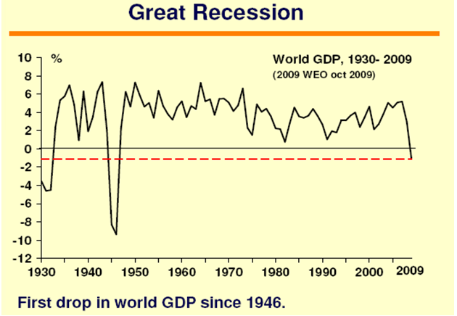
Over the medium term, the hope is that the global economy will resume the rapid and broad-based expansion enjoyed from the early years of the decade until 2008 -without, however, the accompanying financial fragility and the trade imbalances. The main concern now is about the strength and the shape of the recovery.
In its annual report "World Economic Situation and Prospects 2010", the UN said that an increasing number of countries have registered positive quarterly growth of gross domestic product (GDP), along with a notable recovery in international trade and global industrial production. World equity markets have also rebounded and risk premiums on borrowing have fallen.

This optimistic scenario depends to a large extent on a measured rebalancing of the economies of the US, with the world largest deficit, and China, with the world's largest surplus. In view of the central place occupied by the dollar in the international reserve system, it is recognized that international monetary and financial stability depends fundamentally on spending discipline by the US -in line with its income- which would allow for a fundamental and sustained balance-of-payments adjustment. It is likely to lead to tightened global financial conditions with negative effects on several Developing and Emerging Economies (DEEs) in Asia that have structural external deficits and are hence dependent on capital inflows to sustain acceptable growth.
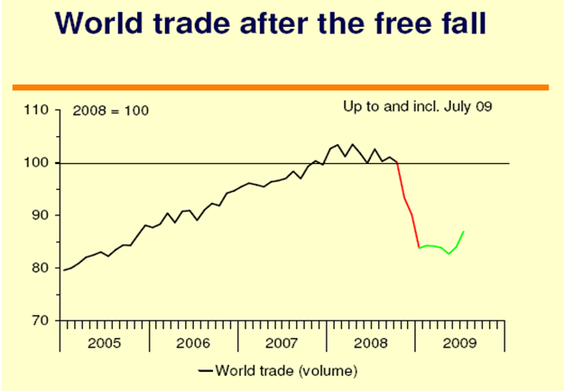
There is more, however, to global imbalances than macroeconomic geography. Income distribution has played an important role and should also be part of the solution. Market-driven globalization has systematically tilted the balance of economic power against labor and in favor of capital, as indicated by the falling share of wage income almost everywhere. This process has, in its turn, produced growing trade imbalances, large shifts in net asset positions of countries, and increased financial fragility, culminating in the most serious post-war economic crisis.
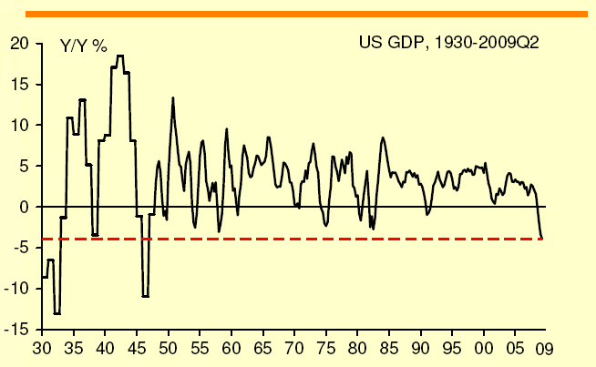
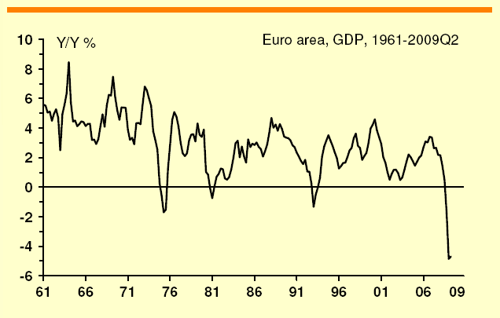
"The economic revival is driven in no small part by the effects of the massive policy stimuli injected worldwide since late 2008. This is an important turnaround after the free fall in world trade, industrial production, asset prices, and global credit availability which threatened to push the global recovery into the abyss of a new Great Depression in early 2009. The recovery is uneven and conditions for sustained growth remain fragile," the UN report cautions.

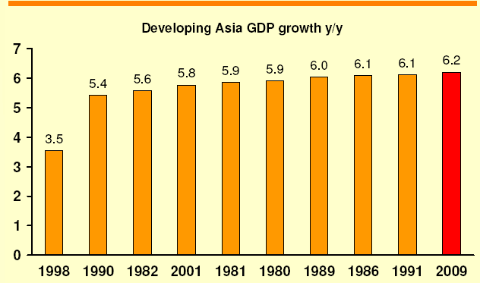

It further warns of the failure to address two risks in particular which could cause the global economy to enter into a double-dip recession. First, is the risk of a premature "exit" from the stimulus measures to prevent further financial sector fallout. Second, is the risk of a renewed significant widening of the global macroeconomic imbalances, especially the United States deficit and mounting external debt, which could cause a hard landing of the US dollar and cause a new wave of financial instability.

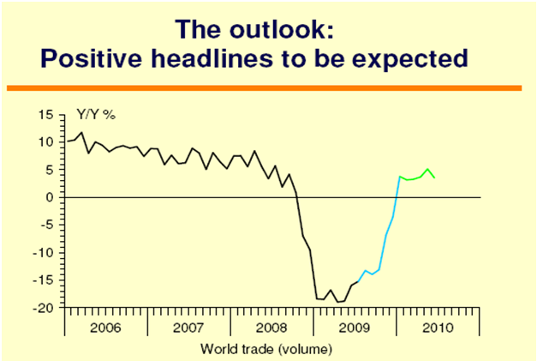
The world economy now faces a serious dilemma: financial consolidation and retrenchment in deficit countries would raise the specter of economic stagnation, while a return to financial bubbles and debt-driven expansion could mean that the next crisis might be even worse and the state could be in a much weaker financial position to respond effectively. But in either case, the adjustments exist only in appearance since, without restoring the balance between labor and capital, neither stability nor growth may be sustained for long.
There is thus a need for adjustment in the major economies with the aim of removing imbalances while ensuring adequate global demand without a return to financial bubbles and debt-driven spending. All these changes need to be complemented with a reform of the global financial architecture so as to ease the payments constraints of deficit and indebted developing countries in Asia.
However, there are no signs that the reorientation of policies needed for such a rebalancing is on the agenda of the major economies or the international community at large. Consequently, the world economy generally and DEEs in Asia particularly may face more serious challenges in coming years than they have seen during the recent global downturn.
As mentioned in the UN report, there is a risk of an early withdrawal of monetary and fiscal stimulus. The report has highlighted two factors on the private sector side that can revive the economy once the government withdraws, namely, consumption and investment.

Many people also believe that trade can be a factor that can bring about a recovery in the world economy. The financial crisis has also significantly affected world trade, says the report. Triggered by a retrenchment in import demand in major developed countries and more restricted access to trade financing, trade flows fell at an annualized rate of between 30% and 50% in most economies in late 2008 and early 2009. Trade flows have recovered since the second quarter of 2009. The rebound has been largely driven by the turn in the global inventory cycle, while import demand from consumption and business investment has remained weak.

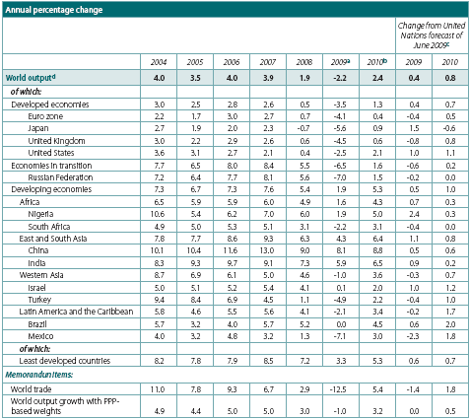

Even given the recent rebound, trade flows for 2009 as a whole are still estimated to decline by more than 12%. A mild growth of 5% is forecast for the volume of world trade in 2010 along with the projected moderate recovery of global aggregate demand.

Economists believe that there is a lot of fragility in both consumption and investment. On the investment side, the capacity utilization is very low. As for consumption, the question is -where are the big stimuli that would increase consumption? Employment is falling and unemployment is rising and that incomes of private households are flat.

It is very hard to see from the private sector that there will be a strong stimulus coming in the course of the next year. That leads to the conclusion that "what we have seen is to a very large extent the effect of governments' stabilizing action, and if that is withdrawn, there is a real big danger of a second-dip recession occurring".

There is a clear disconnect between the financial markets and the real economy, in that the financial markets "recovered" much earlier than the real economy. This has a number of dangers citing amongst others several new bubbles in the world economy that have inflated in the last year.

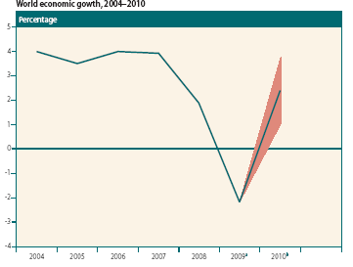
According to the UN report, global equity markets have rebounded and risk premiums on lending have fallen. International trade and global industrial production have also been recovering noticeably, with an increasing number of countries registering positive quarterly growth of gross domestic product (GDP).

However, credit conditions are still tight in major developed economies, where many major financial institutions need to continue the process of de-leveraging and cleansing their balance sheets. The rebound in domestic demand remains tentative at best in many economies and is far from self-sustaining.

Developing countries, especially those in Asia, are expected to show the strongest recovery in 2010. Nonetheless, growth is expected to remain well below potential and the pre-crisis levels of performance in the developing world.

The US economy is expected to grow by 2.1% in 2010, following an estimated downturn of 2.5% in 2009. Recovery in both the European Union (EU) and Japan is projected to be much weaker, reaching GDP growth of no more than 0.5% and 0.9%, respectively, in 2010. At this pace of recovery, the major developed economies are not expected to provide a strong impetus to global growth in the near term. Output growth in the Asian developing countries, in contrast, is expected to recover at a faster pace and to reach 5.3% in 2010, up from 1.9% in 2009, but will remain well below the pre-crisis pace of more than 7% per annum.

However, as global demand is still weak, a premature withdrawal of those measures could abort the incipient recovery. Going forward, the most pressing policy challenges over the near term include maintaining the momentum of economic recovery through economic stimulus measures and re-balancing global growth towards a more sustainable path so as to avoid a re-emergence of the global imbalances, while, at the same time, facilitating high growth, especially for the Asian developing countries, and addressing the climate change challenge.

Deflation, rather than inflation, should be a policy priority for many Asian countries in the near term. Inflationary pressures as a consequence of ballooning government deficits and the ample liquidity injected during the crisis, if they emerge, will be more of an issue in the medium run, after the recovery has become more solid, and should not be of immediate concern as indicated in the UN report.

Conclusion

Following a sharp deterioration in late 2008 and early 2009, the international economic environment for the Asian developing countries and the economies in transition particularly has been stabilizing and improving, but it remains daunting. Certain categories of private capital flows are returning to some emerging economies, and external financing costs are normalizing, but the general external financing conditions for developing countries are expected to remain tight in 2010. Both global trade flows and world market prices of primary commodities rebounded during 2009, but the contribution of international trade to growth in Asian developing countries is not expected to recover its full strength in the near term.

